Integrating jenkins with git from different branches qa,dev,prod And deployment through ec2
By - BHAVANA JUNGHARI
- Create 3 private repository as qa,dev,and prod
- Installing httpd and start that services on jenkins master
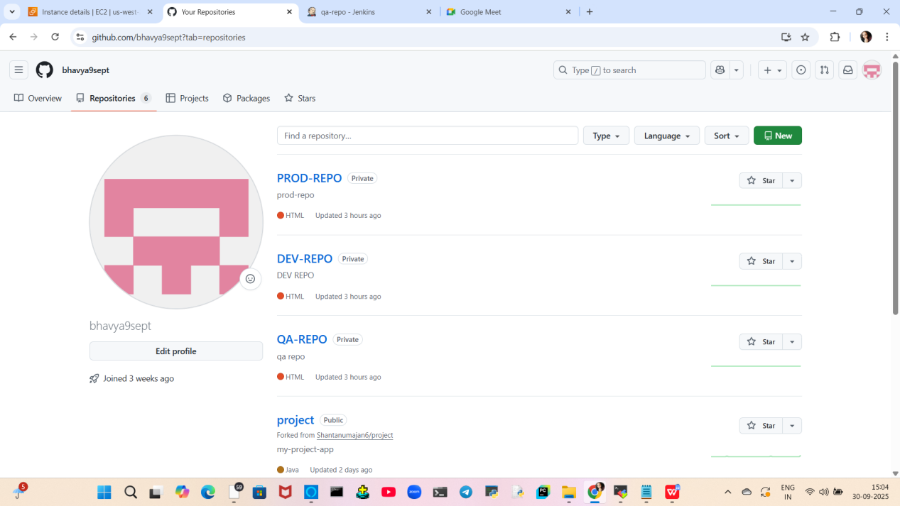
- create index.html file in all 3 branches that is qa,dev and prod branch.
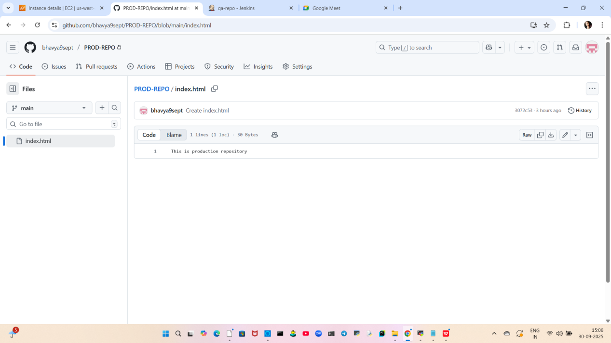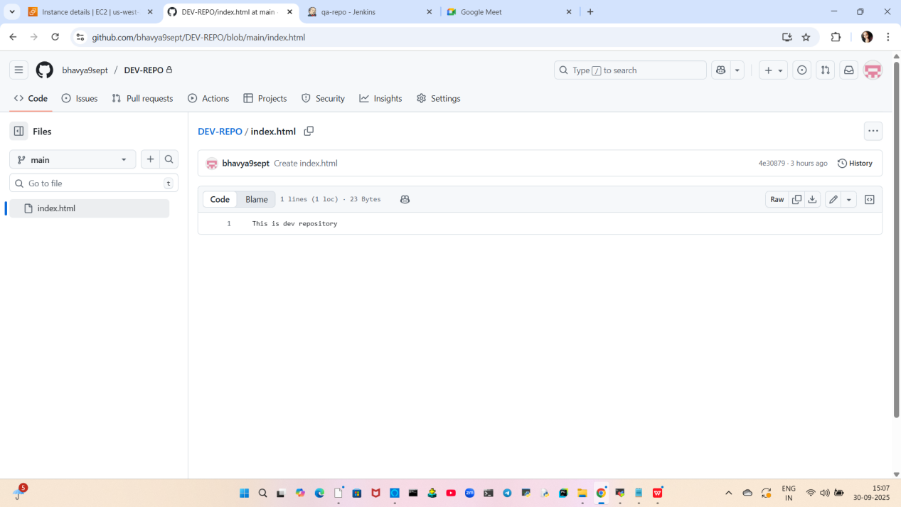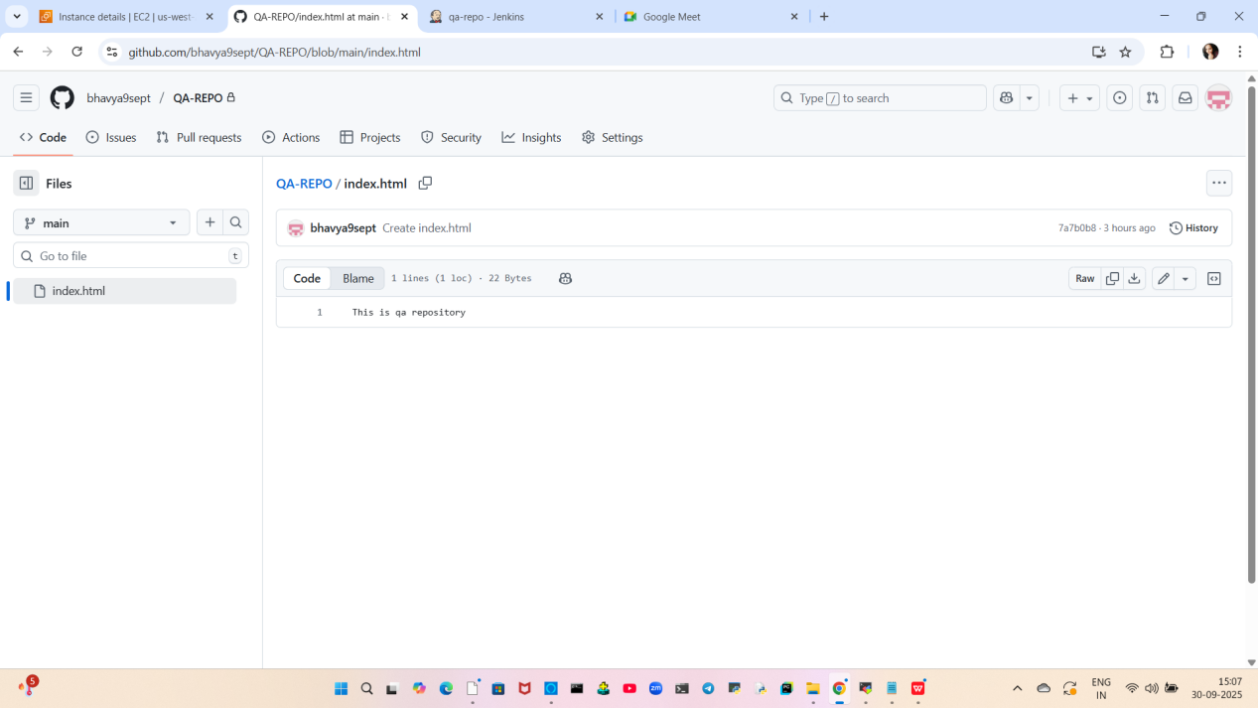
- Create job on jenkins dashboard
- 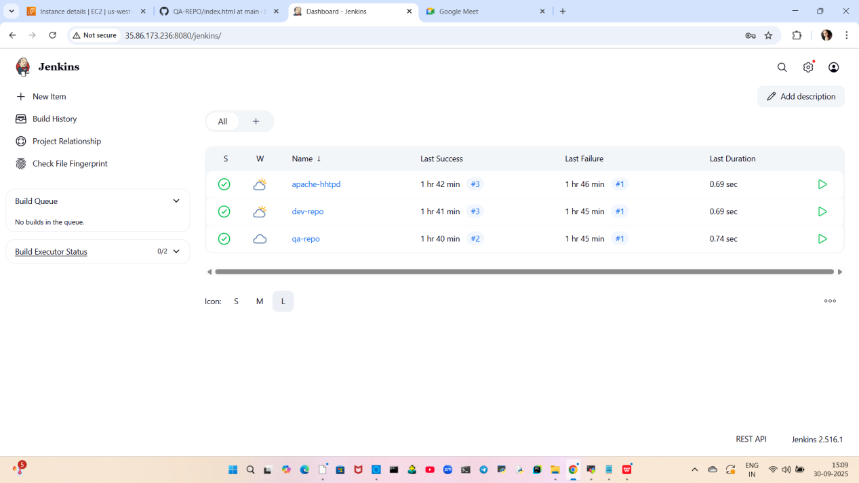
- For job configuration:
- As repository is private so we add credentials I.e git token.
- Discard old builds
- Integrating git repo urlwith branch.
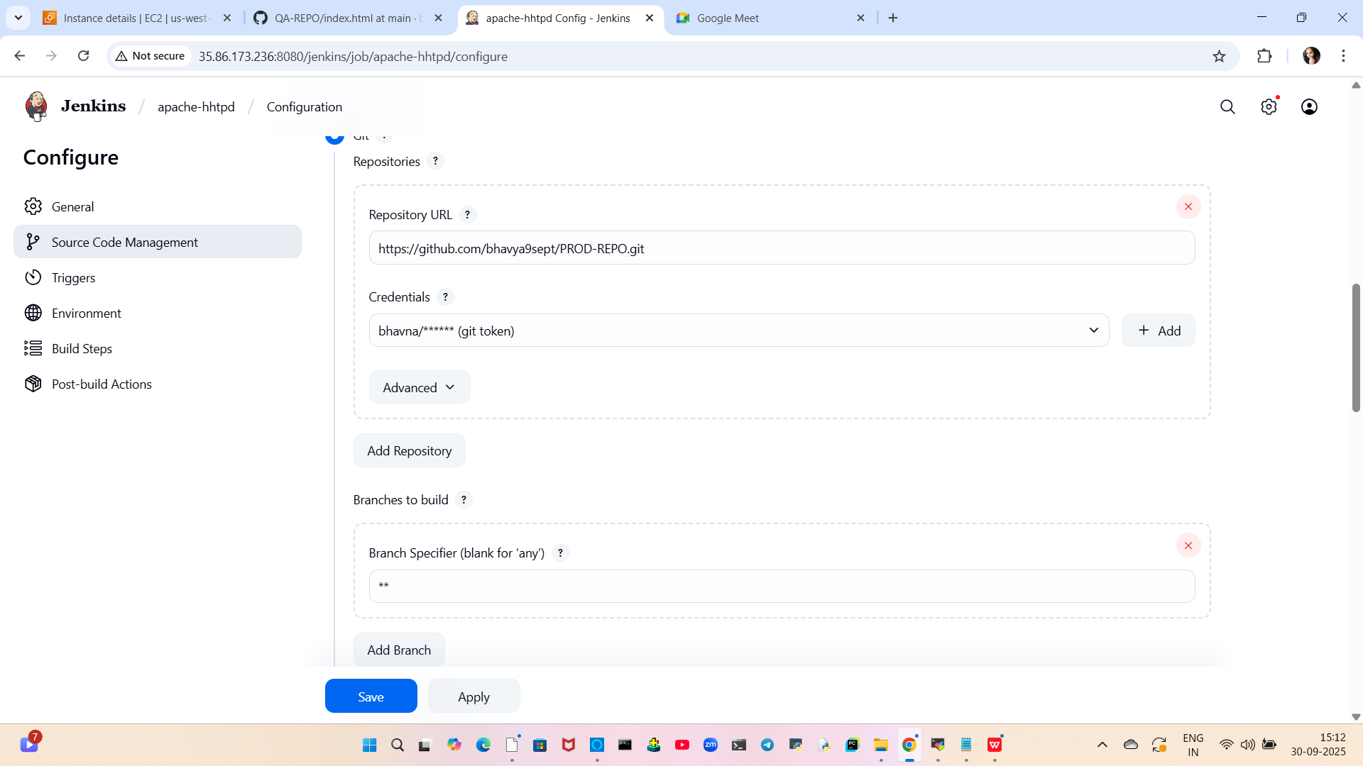
- Delete workspace before build
- Add build step using shell
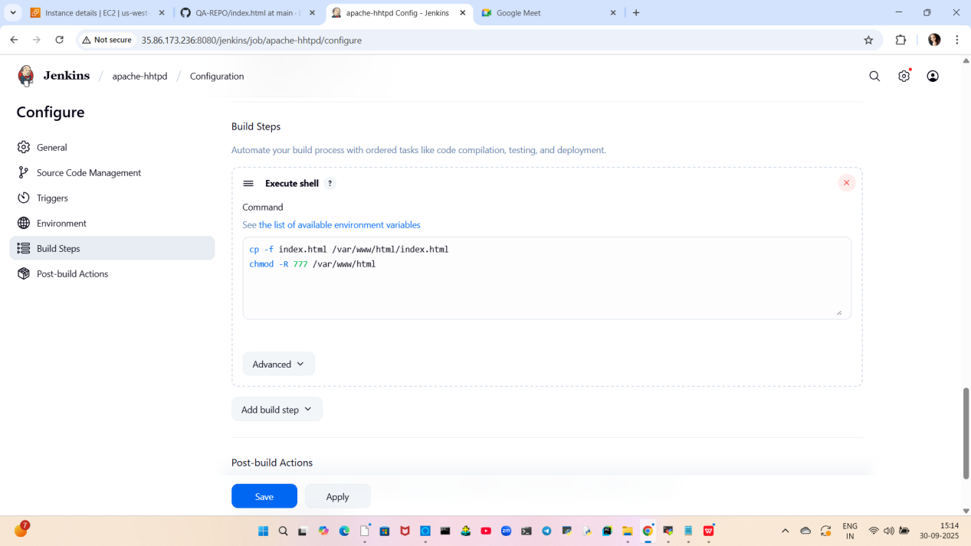

- Now build the respective job where index.html file context can be acess on browser. For this specific job 1st build this job and then try to fetch with the help of pubkic ip
- 
Work done!!

